**A**

**Project Report**

**On**

**Aquatic FishRobo**

Guided by

**Dr.N.P.Futane**

Submitted By

**1. Sagar Sopan Narkhede (17231014)**

**2. Omkar Gorakhnath Sutar (16132063)**

**3. Pooja Kisan Katkar(17231011)**

**4. Ashlesha Maruti Borade (16131036)**



**Department of Electronics and Telecommunication Engineering**

**GOVT. COLLEGE OF ENGINEERING AND RESEARCH**

**AWASARI (KHURD), DIST- PUNE 412405**



**CERTIFICATE**

*This is to certify that following students of B.E. (Electronics and Telecommunication), have done bonafide work on the project stage-I entitled –* ***“AQUATIC FISHROBO”.***

*They are allowed to submit this work to the Savitribai Phule Pune University towards partial fulfilment of the requirement for the award of Bachelor of Engineering (Electronics and Telecommunication) during the year 2019-2020.*

*.*

**1. Sagar Sopan Narkhede (17231014)**

**2. Omkar Gorakhnath Sutar (16132063)**

**3. Pooja KisanKatkar (17231011)**

**4. Ashlesha Maruti Borade (16131036)**

**Project Guide Head of Dept. Principal**

**(Dr. N.P. Futane) (Dr.M.S. Nagmode) (Dr. A.S. Pant)**

**INDEX**

|  |  |  |
| --- | --- | --- |
| **Sr. No** | **Table of contents** | **Page No** |
| 1 | Abstract | 4 |
| 2 | Introduction | 5 |
| 3 | Literature review | 7 |
| 4 | Hardware | 9 |
| 1.Electronic System | 10 |
| 2.Mechanical system | 15 |
| 5 | Joystick | 17 |
| 6 | PCB fabrication | 18 |
| 7 | Software | 21 |
| 8 | Algorithm | 23 |
| 9 | Flowchart | 24 |
| 10 | Program | 25 |
| 11 | Cost Estimation | 26 |
| 12 | Advantages | 27  28 |
| 13 | Applications |
| 14 | Future scope | 28 |
| 15 | Conclusion | 29 |

**ABSTRACT**

In the Swachh Ganga mission getting data about the health of the water body, i.e. the measurement of concentration of impurities, temperature etc is essential for creating a more effective plan of action. In this project we unleash our imagination and discover our talent in 3D designing to build a bio-inspired fish robot that is capable of traversing in water to collect data about a water-body's health and transmit it to a buoy. Challenges in this project include: 3D designing and fabrication, PCB designing, Microcontroller programming, wireless communication etc.

**INTRODUCTION**

* The Ganges (or Ganga), the largest river in India, provides water to about 40% of India's population across 11 states, serving an estimated population of 500 million people with more than any other river in the world.
* But this source of life now severely polluted with human waste and industrial contaminants, poses significant threats to human health and the larger environment.
* As engineers , what can we do to help in the Swachh Ganga mission. We know, monitoring the state of a system is an essential part of trying to get it to a desired target
* . In the Swachh Ganga mission getting data about the health of the water body, i.e. the measurement of concentration of impurities, temperature etc is essential for creating a more effective plan of action.
* In this project we unleash our imagination and discover our talent in 3D designing to build a bio-inspired fish robot that is capable of traversing in water to collect data about a water-body's health and transmit it to a buoy.
* Challenges in this project include: 3D designing and fabrication, PCB designing, Microcontroller programming, wireless communication etc.
* In this project, the Aquatic Robot designed by the us needs to swim through a defined course and trigger “Anchored Buoys” on its way. The course is defined by the position and orientation of“Gateways”. We also designed a wireless joystick to control the Aquatic Robot.

**Arena Configuration:**

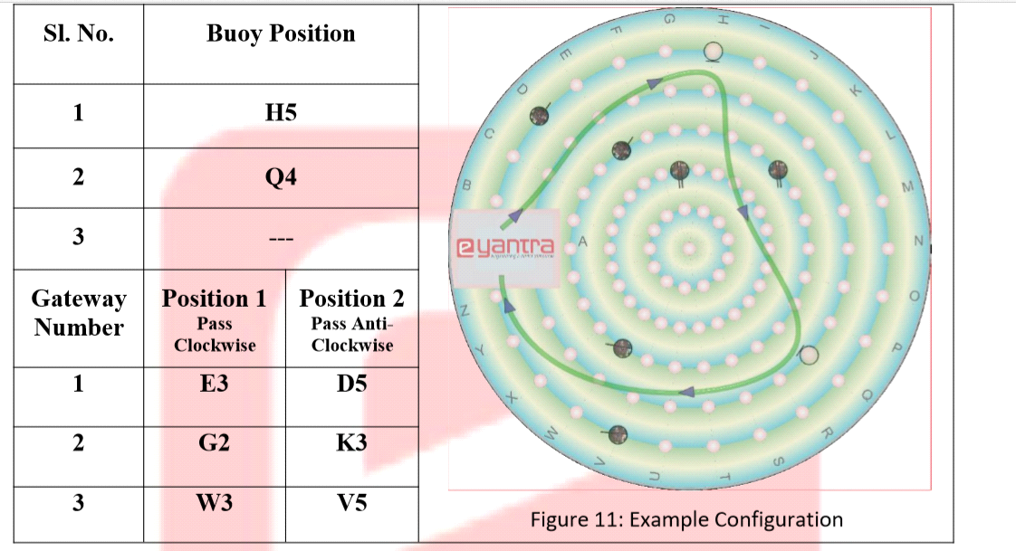

**Figure: Arena Configuration.**

**LITERATURE REVIEW**

The Ganges (or Ganga), the largest river in India, provides water to about 40% of India's population across 11 states, serving an estimated population of 500 million people with more than any other river in the world. But this source of life now severely polluted with human waste and industrial contaminants, poses significant threats to human health and the larger environment. As engineers , what can we do to help in the Swachh Ganga mission. We know, monitoring the state of a system is an essential part of trying to get it to a desired target. In the Swachh Ganga mission getting data about the health of the water body, i.e. the measurement of concentration of impurities, temperature etc is essential for creating a more effective plan of action. In this theme we unleash our imagination and discover our talent in 3D designing to build a bio-inspired fish robot that is capable of traversing in water to collect data about a water-body's health and transmit it to a buoy. We divide the Project into a number of tasks to build the Aqaurit Robot in a step- by-step manner making the process more interesting for us. Challenges in this Project include: 3D designing and fabrication, PCB designing, Microcontroller programming, wireless communication etc. We tiik inspiration from the variety of fishes in the aquatic world and created the locomotion of that fish while designing their robot. After building the bot,we need to navigate it in an arena.

The reference used for the microntroller boards and their specifications are:

* **Arduino Nano (ATmega328)**

The Arduino Nano is a small, complete, and breadboard-friendly board based on the ATmega328P; it offers the same connectivity and specs of the Arduino Uno board in a smaller form factor.[1][2] The Arduino Nano is programmed using the Arduino Software (IDE), Arduino.cc's Integrated Development Environment common to all our boards and running both online and offline.

* Arduino Nano(ATmega328P) technical specification

|  |  |  |
| --- | --- | --- |
| **SRNO** | **COMPONENT** | **SPECIFICATION** |
| 1 | Microcontroller: | ATmega328 |
| 2 | Architecture: | AVR |
| 3 | Operating Voltage: | 5 V |
| 4 | Flash Memory | 32 KB of which 2 KB used by bootloader |
| 5 | SRAM | 2 KB |
| 6 | Clock Speed | 16 MHz |
| 7 | Analog IN Pins | 8 |
| 8 | EEPROM | 1 KB |
| 9 | DC Current per I/O Pins | 40 mA (I/O Pins) |
| 10 | Input Voltage | 7-12 V |
| 11 | PWM Output | 6 |
| 12 | Power Consumption | 19 mA |
| 13 | PCB Size | 18 x 45 mm |

**HARDWARE**

* **ROBOT**

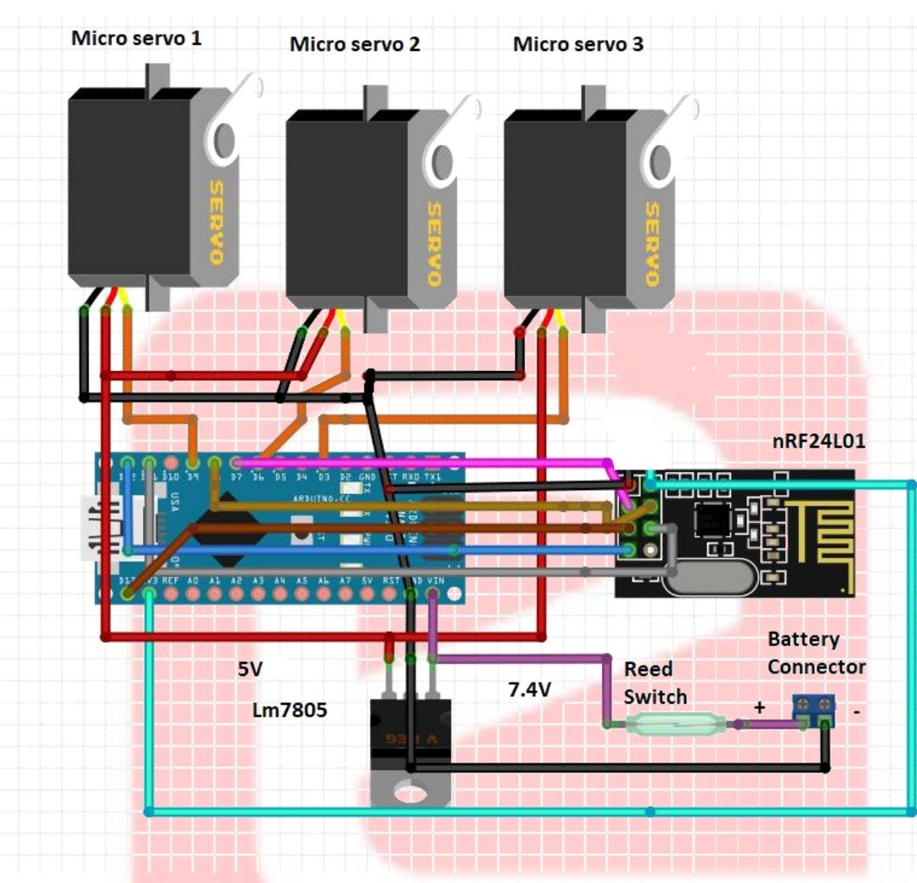

**1.Electronic system:**

**1.1 Arduino Nano 328**

The controller performs the various controlling actions & manages communication between different units of system like sensors, actuators, motor driver, etc. for data analysis & further operation.

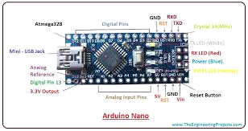

**1.2 Joystick:**

We have designed the joystick module to control the Aquatic Robot wirelessly.

Grove - Thumb Joystick is a Grove compatible module which is very similar to the 'analog' joystick on PS2(PlayStation 2) controllers. The X and Y axes are two ~10k potentiometers which control 2D movement bygenerating analog signals. The joystick also has a push button that could be used for special applications.

When the module is in working mode, it will output two analog values, representing two directions.Compared to a normal joystick, its output values are restricted to a smaller range (i.e. 200~800), only when pressed that the X value will be set to 1023 and the MCU can detect the action of pressing

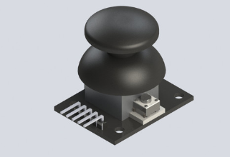

**1.3Servo Motor:**

A servomotor is a rotary actuator or linear actuator that allows for precise control of angular or linear position, velocity and acceleration. It consists of a suitable motor coupled to a sensor for position feedback. It also requires a relatively sophisticated controller, often a dedicated module designed specifically for use with servomotors.

Using these Servo motors we will give motion to our Aquatic Robot like fish.

The Towerpro MG90S Mini Digital Servo is 360° rotation servo. It is a Digital Servo Motor which receives and processes PWM signal faster and better. It equips sophisticated internal circuitry that provides good torque, holding power, and faster updates in response to external forces.The good optimized performance and reliability of our servos have made them the favourite choice of many RC hobbyists.

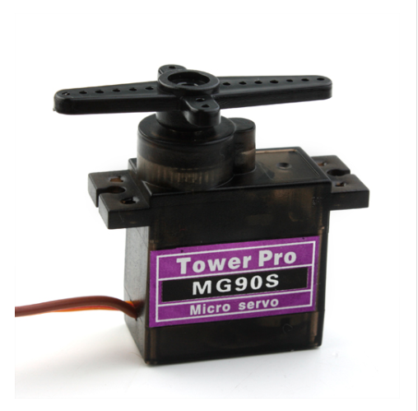

**1.4 Li-ion Battery (2200 mAh, 11V):**

To supply the power for the different units of the robot.This battery pack is made up of best quality tested ICR 18650 2000mAh 20C Lithium-Ion Batteries and BMS circuit. It is small in size and weight compared to Ni-Cd, Ni-MH, and Lead Acid Batteries. With the inbuilt Charge protection circuit, the battery pack can be directly charged with the DC power Adapter, so need not use the specialized battery chargers and worry about overcharging.

We build these battery packs in diverse range to fulfil 7.4V to 14.8 V and differential capacity requirement. This battery pack is very convenient to recharge and install in your project requirement with 5mm DC female jack for changing and Nylon Female T-connector for discharging or connecting to your applications.

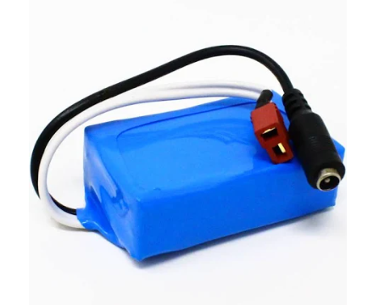

**1.5 NRF24L01 Transceiver**

The nRF24L01+ is a single chip 2.4GHz transceiver with an embedded baseband protocol engine (Enhanced ShockBurstTM), suitable for ultra low power wireless applications. The nRF24L01+ is designed for operation in the world wide ISM frequency band at 2.400 - 2.4835GHz. You can operate and configure the nRF24L01+ through a Serial Peripheral Interface (SPI). The register map, which is accessible through the SPI, contains all configuration registers in the nRF24L01+ and is accessible in all operation modes of the chip. The radio front end uses GFSK modulation. It has user configurable parameters like frequency channel, output power and air data rate. nRF24L01+ supports an air data rate of 250 kbps, 1 Mbps and 2Mbps. The high air data rate combined with two power saving modes make the nRF24L01+ very suitable for ultra low power designs.nRF24L01+ is drop-in compatible with nRF24L01 and on-air compatible with nRF2401A, nRF2402, nRF24E1 and nRF24E2. Intermodulation and wideband blocking values in nRF24L01+ are much improved in comparison to the nRF24L01 and the addition of internal filtering to nRF24L01+ has improved the margins for meeting RF regulatory standards. Internal voltage regulators ensure a high Power Supply Rejection Ratio (PSRR) and a wide power supply range.

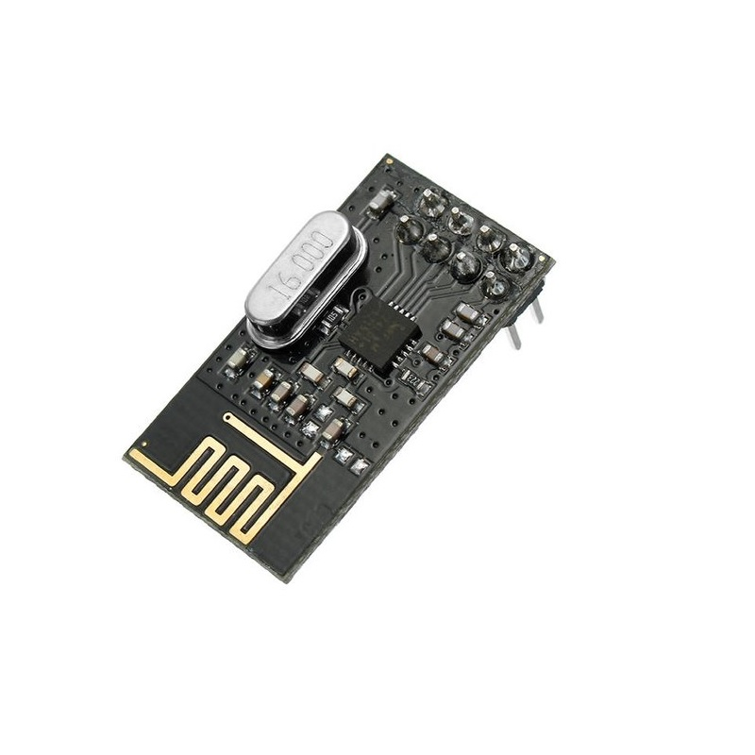

* 1. **Reed Switch:**

This is a small device called a reed switch. When the device is exposed to a magnetic field, the two ferrous materials inside the switch pull together and the switch closes. When the magnetic field is removed, the reeds separate and the switch opens. This makes for a great non-contact switch. This switch can carry up to 1.2A.

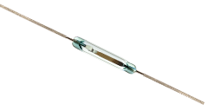

* 1. **Hall Effect Sensor:**

A Hall effect sensor is a device that is used to measure the magnitude of a magnetic field. Its output voltage is directly proportional to the magnetic field strength through it.Hall effect sensors are used for proximity sensing, positioning, speed detection, and current sensing applications.Frequently, a Hall sensor is combined with threshold detection so that it acts as and is called a switch. They can also be used in computer keyboards, an application that requires ultra-high reliability. Another use of a Hall Sensor is in the creation of MIDI organ pedal-boards, where the movement of a 'key' on the pedal-board is translated as an on/off switch via Hall Sensors.

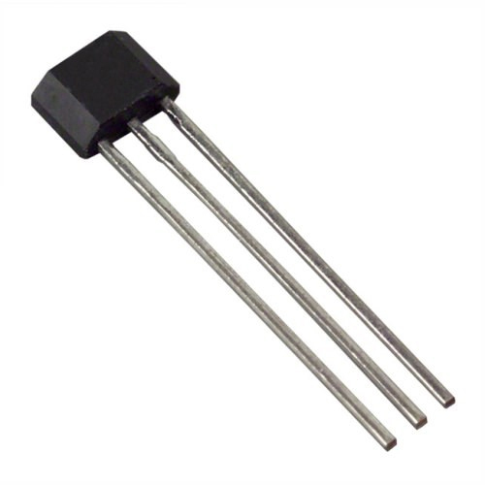

**2.Mechanical system**

**2.1 Servo Motor:**

Servo motor is used for giving "S" motion to the fish Robot. There are 5 Servo motor used

1.Head Servo: which will control middle part.

2.Two Fin Servo: To control Fin motion

Middle Servo: To control second part

Tail Servo: To control Tail of the Fish

**2.2 3D Printed Fish:**

It is the hardware body structure of the robot to constrain all the components required for the robot. For the fabrication of Nylon 6 (PA6/66)

A filament that is ideal for more experienced users of 3D printers. Nylon is strong and durable. Nylon can be used as flexible hinge when printed thinly or can be strong enough to use for engineering applications such as gears due to low friction qualities and where subject to low force loadings. A heated print bed is recommended when printing with Nylon to prevent warping. Our Nylon is made using the purest raw materials without fillers. Our crosssectional roundness is consistent throughout the whole spool to ensure that a reliable printing experience is achieved over repeated prints. Our filaments are free from air bubbles or voids that help to ensure accurate and high definition printing results.

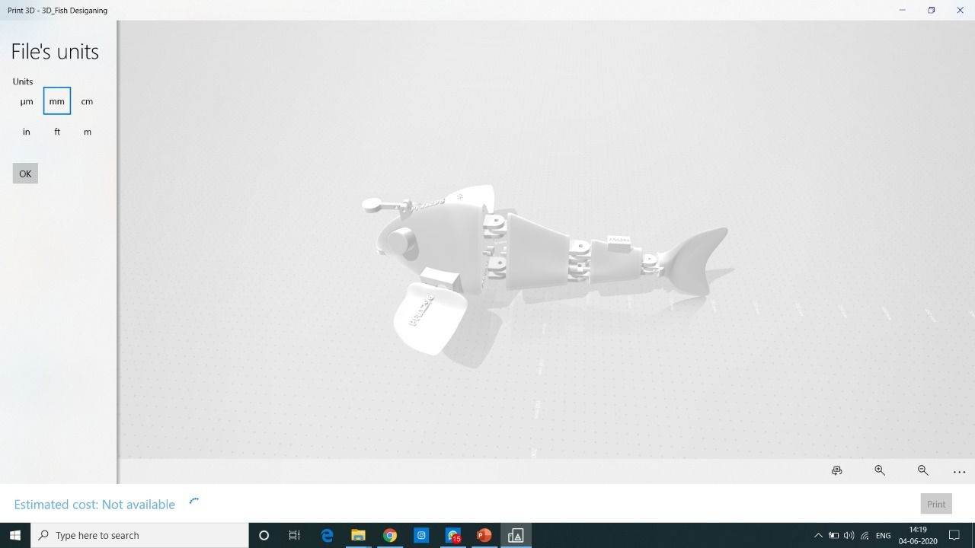

**2.3Gateways:**

The pair of objects that the Aquatic Fish Robot needs to go through in the assigned sequence and also in the direction specified. Dimension of the cylinder are 70mm ± 5mm in diameter and 170mm in height.

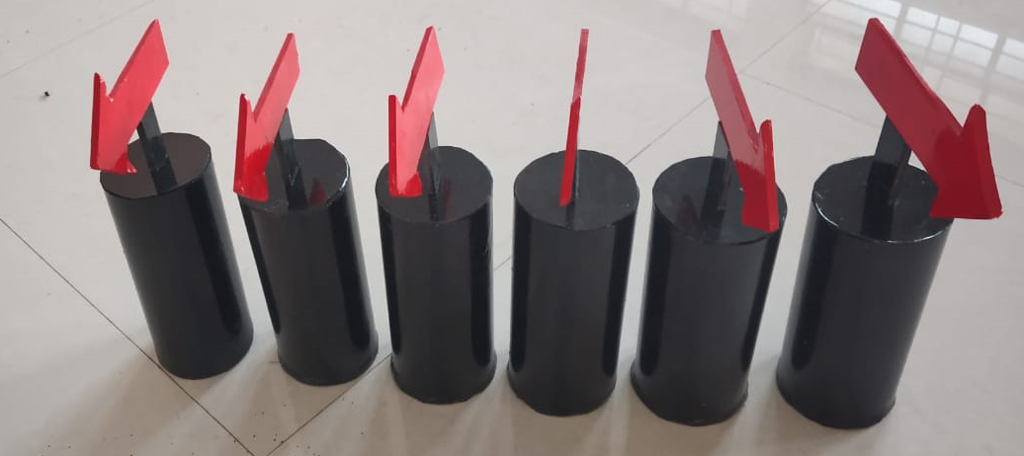

**2.4 Anchored Buoys:**

The object the Aquatic Fish Robot needs to trigger. The Anchored Buoy is a structure to be placed on the floor of the pool.The structure has two major parts: Tower that indicate when the Patrol Fish robot triggers the sensor. The dimension of the cylinder of the Buoy is 70mm ± 5mmindiameterand170mminheight.A circuit board in the tower of the buoy has a latch circuit that switches the LEDs ON as soon as hall effect sensors senses the field of the magnet on the Patrol Fish and leaves it on for the rest of the run.

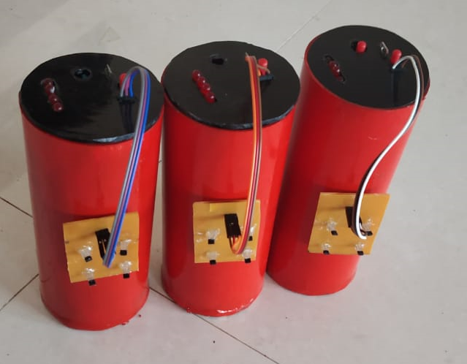

**JOYSTICK**

* **Description:**

**1.PCB design forWireless Joystick and hall effect sensor:**

We have designed a PCB for Wireless Joystick in Eagle software.

**Required Hardware for Wireless Joystick:**

1. ArduinoNanoboard

2. NRF24L01Transceiver

3. Joystickmodule

4. Connectors

**Joystick module**

The Joystick is nothing but two potentiometers that allow us to measure the movement of the stick in 2-D. Potentiometers are variable resistors and, in a way, they act as sensors providing us with a variable voltage depending on the rotation of the device around its shaft.(source)

**Buzzer:**

Buzzer Module for Arduino is an audio signaling device. Buzzer rings out as long as it receives signal in its data pin.

* **Connecting Hardware for Wireless Joystick (Transmittersystem):**

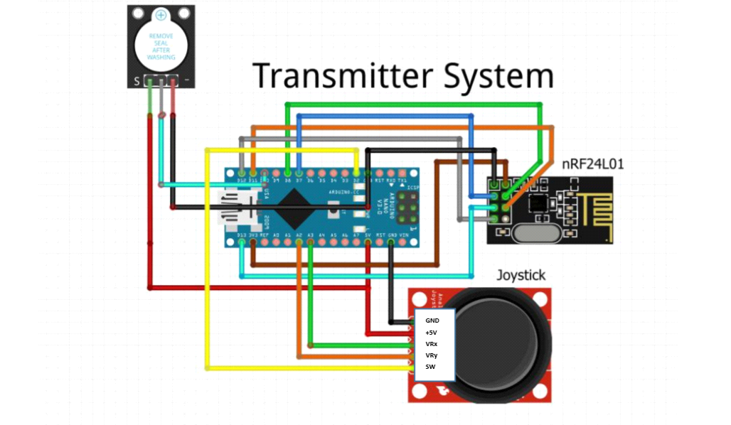

**Figure: Transmitter System connections**

**PCB FABRICATION**

**Printed Circuit Board(PCB)**

PCB are mainly classified into two types:

➢ Through Hole : Through-hole technology is the process by which component leads are placed into drilled holes on a bare PCB. Through-hole components are best used for high-reliability products that require stronger connections between layers.

➢ Surface mount: In Surface Mount Technology components are secured only by solder on the surface of the board. An SMT component is usually smaller than its through-hole counter part because it has either smaller leads or no leads at all.

* **PCB fabrication.**

**Step1: Printing the board design file:**

After completion of PCB board design file, from board file open visibility settings by clicking on the button on the top left of the screen. Make only the “Bottom”, “Pads” and “Dimension” layers visible and hide all other layers

**Step2: Toner Transfer:**

Cut the copper clad of the approximate size of your board file. Place the printed photographic paper on copper clad and start pressing it with a heated iron

**Step3: Etching process:**

Take water in a small plastic container. Add small amount of ferrous chloride solution to it. Place the toned board in the solution as Stir the board in the solution.Untoned part will start etching.

**Step4:Cleaning:**

After etching wash the board with water. Use acetone to remove the toned paper and marker pen ink

**Step5:Drilling:**

Drill the holes for pads

**Step6: Testing:**

Check the continuity test of all the tracks by mustimeter. Removetheshortedtracks.

**Step7: Soldering:**

Place the component at the top board of the board and start soldering it to the track with solder wire.

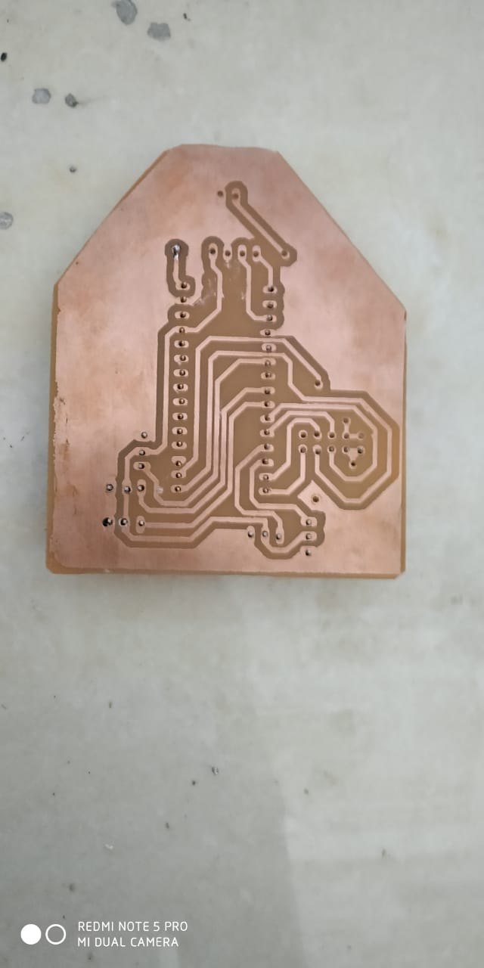

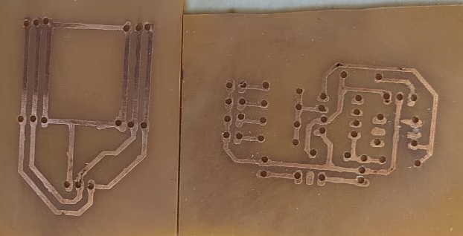

* **Waterproofing:**

**1.Waterproofing the Fish Body:**

Waterproofing of the joints of the Fish body is done by using,

1.Candle Wax

2.Balloons

3.Silicone Gel

**2. Waterproofing the Elctronic Components:**

1. Nail Polish Coating

2. Silicone paste/Adhesive

**SOFTWARE**

* **Blender:**



Blender is the free and open source 3D creation suite. It supports the entirety of the 3D pipeline—modeling, rigging, animation, simulation, rendering, compositing and motion tracking, even video editing and game creation. Advanced users employ Blender’s API for Python scripting to customize the application and write specialized tools; often these are included in Blender’s future releases. Blender is well suited to individuals and small studios who benefit from its unified pipeline and responsive development process.

* **Arduino IDE:**



The Arduino Integrated Development Environment (IDE) is a cross-platform application (for Windows, macOS, Linux) that is written in functions from C and C++. The Arduino IDE supplies a software library from the Wiring project, which provides many common input and output procedures. User-written code only requires two basic functions, for starting the sketch and the main program loop, that are compiled and linked with a program stub main() into an executable cyclic executive program with the GNU toolchain, also included with the IDE distribution..

* **Autodesk Fusion 360:**



**Fusion 360** is a cloud-based 3D CAD, CAM & CAE design tool from Autodesk. It is available on a number of platforms including Windows, Mac & In-Browser. It is functionally similar to other 3D software like Solidworks, Siemens NX, Inventor or Catia. It is a very full featured program and is available to hobbyists and start-up businesses for no cost.

* **Eagle:**



Acronym for Easily Applicable Graphical Layout Editor, is a design **software** by Cadsoft Computers. It is widely **used** by educationalists, students, hobbyists and professionals because of its rich yet simple interface with large component library cross-platform support on Windows, Mac and Linux too! **EAGLE** is a scriptable [electronic design automation](https://en.m.wikipedia.org/wiki/Electronic_design_automation) (EDA) application with [schematic capture](https://en.m.wikipedia.org/wiki/Schematic_capture), [printed circuit board](https://en.m.wikipedia.org/wiki/Printed_circuit_board) (PCB) [layout](https://en.m.wikipedia.org/wiki/PCB_layout), [auto-router](https://en.m.wikipedia.org/wiki/Auto-router) and [computer-aided manufacturing](https://en.m.wikipedia.org/wiki/Computer-aided_manufacturing) (CAM) features.

**ALGORITHM**

1.Start

2. Trigger the Aquatic Robot using Magnet .It will turn the Robot on.

3. Now turn the Joystick too.

4. Establish the NRF Connections Properly and indicate it by glowing LED on Joystick.

5. Use Joystick to Send the Character Massage to NRF Reciever with the Encoded Servo Action.

6. After receiving the Text properly servo motor will move as per given angle in the Script.

7. Each Joystick value of X and Y will give each servo different Angles and Fish will get its motion.

8. .Using the Joystick Control the Fish in Water.

9.Pass the Robot safely through the the Gateways.

10. Trigger the Boys with the Magnet on the Robot using Hall effect Sensor.

11. Repeat 9 and 10 until Robot reaches at the Start point again.

12. End

**FLOWCHART**

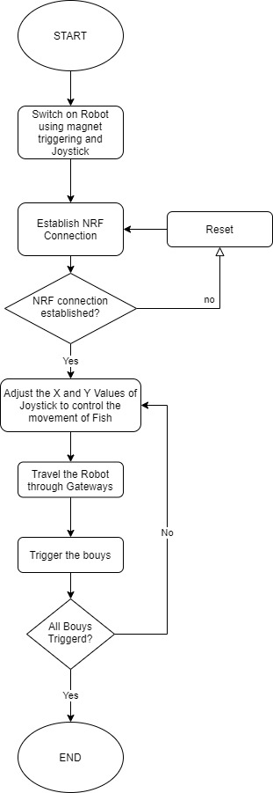

**PROGRAM**

<https://drive.google.com/drive/folders/1aHHeiEQJljIpSD1Fyj1P6sBwNRnK6c__?usp=sharing>

**COST ESTIMATION**

|  |  |  |  |  |
| --- | --- | --- | --- | --- |
| **Sr No.** | **Name of Components** | **Quantity** | **Unit Cost(Rs)** | **Total** |
| 1 | Arduino Nano (ATmega 328 Controller) | 2 | 1563 | 1563 |
| 2 | NRF24L01 | 2 | 220 | 440 |
| 3 | Joystick Module | 1 | 75 | 75 |
| 4 | Buzzer Module | 2 | 20 | 40 |
| 5 | Servo Motor | 5 | 195 | 975 |
| 6 | Battery(5V) | 4 | 25 | 100 |
| 7 | Battery(9V) | 2 | 470 | 940 |
| 8 | Reed Switch | 1 | 15 | 15 |
| 9 | Slide Switch | 3 | 64 | 192 |
| 10 | Magnet | 2 | 15 | 30 |
| 11 | Push Button | 7 | 15 | 105 |
| 12 | Timer IC555 | 3 | 225 | 675 |
| 13 | Hall Effect Sensor | 27 | 20 | 540 |
| 14 | LEDs | 20 | 5 | 100 |
| 15 | Capacitors | 10 | 5 | 50 |
| 16 | Resistors | 10 | 3 | 30 |
| 17 | Programming cable | 2 | 180 | 360 |
| 18 | IC7805 | 2 | 12 | 24 |
| 19 | IC7809 | 2 | 12 | 24 |
| 20 | IC7812 | 1 | 12 | 24 |
| 21 | Water Pool | 1 | 1500 | 1500 |
| 22 | Arena | 1 | 1300 | 1300 |
| 23 | 3D Printing material | 1kg | 1400 | 1400 |
|  | **Total** |  |  | **10502** |

**ADVANTAGES**

* Aquatic Robots are used for research about animals and underwater wildlife.
* Underwater Exploratory Robots can go underwater longer and deeper than humans
* Robots are less likely to get hurt or die on any missions.
* Exploratory robots can gain information that we can’t physically obtain.

**FUTURE SCOPE AND APPLICATIONS**

1. Submarine wireless communication.

2. 3D Game Design Platform.

3. Creating Animated movies.

4. Macrolevel Research on Aquatic life and habitat.

**CONCLUSION**

The project “Aquatic Fish Robot” includes the implementation bio-inspired robot that is capable of traversing in water .This project includes the implementation of various concepts in real time based applications like 3D gaming, 3D animation . The project presents a complete 3D non-linear dynamic model of a biomimetic robotic fish. In this project we done with 3D designing and fabrication, PCB designing and fabrication, Microcontroller programming, wireless communication etc.

**REFERENCES**

* eYANTRA Sponsored by [MHRD](https://mhrd.gov.in/hi/node/2356) under the [National Mission on Education through ICT](https://mhrd.gov.in/technology-enabled-learning-0) program. An initiative by IIT Bombay that aims to create the next generation of embedded systems engineers with a practical outlook to help provide practical solutions to some of the real world problems.

https://www.e-yantra.org

* Autodesk Fusion 360 Tutorials:

<https://www.autodesk.in/products/fusion-360/learn-support>

* Languages :

Arduino IDE: <https://www.arduino.cc/en/Tutorial/HomePage?from=Main.Tutorials>

* <https://easyengineering.net/microprocessor-and-microcontroller-system-by-godse/>
* Book on Programming and Interfacing ATMEL's AVRs
* Software source

Audesk Fusion 360:

<https://www.autodesk.in/campaigns/education/fusion-360?mktvar002=3510851|SEM|GGL_AEX_Fusion-360_APAC_IN_Visits_SEM_BR_New_EX_INQ_3510851_General-Fusion___&gclid=CjwKCAjwt-L2BRA_EiwAacX32ZG_SE8pQGPt72UA9roErpKd1DpoRIBKnX3Hd71v8YmvZIbXKzqOHhoCEfoQAvD_BwE>

* Autodesk Eagle:

<https://www.autodesk.in/products/eagle/free-download>

* Sensors and actuators kit

<https://robu.in/product/arduino-37pcs-sensor-kit-set/>

* e-Yantra Lab Setup Initiative

<https://www.e-yantra.org/elsi>